STATE OF ISRAEL
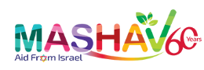
Israel's Agency for International Development Cooperation
Ministry of Foreign Affairs

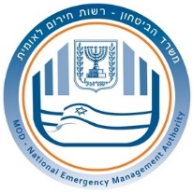
Israel's National Emergency Management Authority

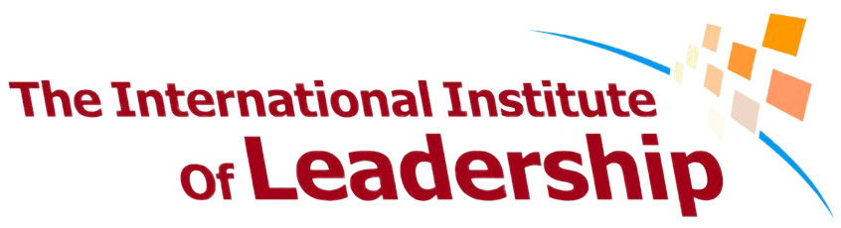
The International Institute of Leadership – Histadrut

MASHAV - Israel’s Agency for International Development Cooperation
and
Israel's National Emergency Management Authority
with
The International Institute of Leadership - Histadrut

invite professionals
to participate in the

International Course:
Emergency Situation Preparedness

April 22nd – May 10th , 2018

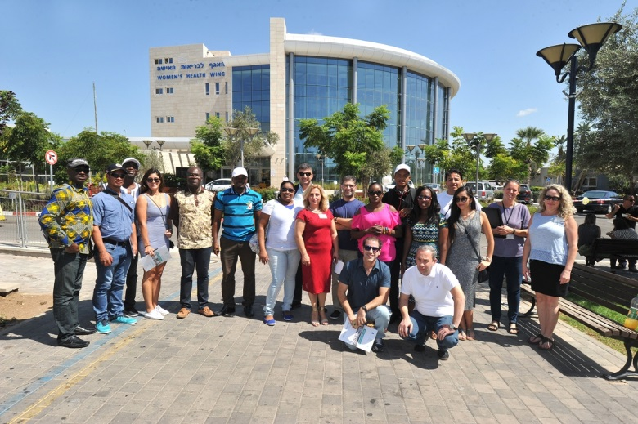

About the Course
Background

The objective of this course is to expose Israeli knowledge and experience in emergency situations to governments all over the world, in order to support LIFE SAVING as an Israeli and Jewish basic value, and to maintain economic, political and social stability in every country.
In recent decades, the Israeli Government and its emergency organizations, as well as the general public, have witnessed the need to cope with mass casualty events, and have acquired the relevant experience to confront them, both natural and manmade.
The course focuses on the complete cycle of the different stages of each emergency (before, during and after), and the different actors involved (Emergency managers, first responders and the civilian population).

Aims

The main goals of the course are to assist the authorities to formulate a National Response Plan to Crisis, by introducing them with the Israeli preparedness system in order to manage crisis.
The leading focus during the seminar will be DECITION MAKING concerning crisis management. All issues presented and discussed in the seminar will be emphasizing the main subject.

Main Subjects

- Population preparedness; Public instructions, public behavior.
- Principals of critical infrastructures protection.
- Managing a CBRN event.
- Use of early warning systems, as a critical stage of crisis mitigation.
- Principals for building population resilience within the communities.
- Medical system response in disasters. (EMS, hospitals, community medical services).
- Israeli Emergency organization (HFC, NEMA, Fire Brigade, Police, EMS)
- Response and preparedness for incidents involving Hazard Materials.
- Command and control methodology, facilities and systems.

Application

Application Requirements

The course is oriented to senior members of the different agencies that take part in a mass casualty event:
- Relevant National, regional or local governmental authorities.
- Police forces.
- Rescue and firefighting units.
- Military forces.
- Healthcare system.
- Relief and welfare agencies.
- Relevant civil society organizations / NGO's.

Application forms
Application forms and other information may be obtained at the nearest Israeli mission or at MASHAV’s website: http://mashav.mfa.gov.il/MFA/mashav/Courses/Pages/default.aspx.
Completed application forms, including the medical form, should be sent to the relevant Israeli mission in the respective country by March 9, 2018, and will be followed by an interview.

General Information

Arrival and Departure
Arrival date: 22/4/2018
Opening date: 23/4/2018
Closing date: 9/5/2018
Departure date: 10/5/2018

Participants must arrive to the training center on the arrival date, and leave on the departure date. Early arrivals/late departures if required, must be arranged by the participants themselves, directly with the hotel/center, and must be paid for by the participant him/herself.

Location and Accommodation
MASHAV and N.E.M.A. award a limited number of scholarships. The scholarship covers the cost of the training program including lectures and field visits, full board accommodation in double rooms (two participants per room), health insurance (see below) and transfers to and from the airport. Airfares and daily allowance are not included in the scholarship.

Health Services
Medical insurance covers medical services and hospitalization in case of emergency. It does not cover the treatment of chronic or serious diseases, specific medications taken by the participant on a regular basis, dental care and eyeglasses. Health authorities recommend that visitors to Israel make sure they have been inoculated against tetanus in the last ten years. Subject to the full binding policy conditions. Participants are responsible for all other expenses.

The course will be held at the International Institute of Leadership – Histadrut, situated
in Beit-Berl, Kfar Sava. Participants will be accommodated at the International Institute in double rooms (two participants per room).

About MASHAV
MASHAV – Israel’s Agency for International Development Cooperation is dedicated to providing developing countries with the best of Israel’s experience in development and planning. As a member of the family of nations, The State of Israel is committed to fulfilling its responsibility to contribute to the fight against poverty and to the global efforts to achieve sustainable development. MASHAV, representing Israel and its people, focuses its efforts on capacity building, sharing relevant expertise accumulated during Israel's own development experience to empower governments, communities and individuals to improve their own lives.
MASHAV’s approach is to ensure social, economic and environmental sustainable development, and is taking active part in the international community’s process of shaping the Post-2015 Agenda, to define the new set of the global Sustainable Development Goals (SDGs).
MASHAV’s activities focus primarily on areas in which Israel has a competitive advantage, including agriculture and rural development; water resources management; entrepreneurship and innovation; community development; medicine and public health, empowerment of women and education. Professional programs are based on a “train the trainers” approach to institutional and human capacity building, and are conducted both in Israel and abroad. Project development is supported by the seconding of short and long-term experts, as well as on-site interventions. Since its establishment, MASHAV has promoted the centrality of human resource enrichment and institutional capacity building in the development process – an approach which has attained global consensus.
http://mashav.mfa.gov.il
https://www.facebook.com/MASHAVisrael

About N.E.M.A: Israel's National Emergency Management Authority - Ministry of Defense
NEMA (est. 2007) is an independent authority in Israel's M.O.D. subordinated directly to the Minister of Defense. The organization's main goal is to prepare Israel’s homeland to successfully face emergency situations by coordinating and directing government offices, local authorities and relevant organizations. NEMA serves as a coordinating body under The Minister of Defense (MOD) in order to help him manage his responsibility in emergency situations in the civil arena. NEMA staff is responsible for several roles in routine and in emergency. During routine, the organization is tasked with prioritizing potential threats to the civilian sphere, defining preparedness criteria, and coordinating response protocols, among other responsibilities. In a time of emergency, NEMA is charged with operating the National Emergency Management Center (NEMC), consolidating real-time situation analysis, and presenting assessments to the MOD along with recommendations. NEMA then directs the implementation of MOD's decisions.
About The International Institute of Leadership - Histadrut
In 1958 the Histadrut – The General Federation of Workers in Israel, and MASHAV – Israel’s Agency for International Development Cooperation, established the International Institute of Leadership. Its vision is to improve socio−economic conditions in developing countries and to promote coexistence and democracy around the world.
With more than 50,000 Alumni from over 140 countries, the International Institute's goal is to train leaders to act as change agents and catalysts for development in their communities and their countries, and to strengthen the communities’ social structure from a personal point-of-view that focuses on the citizens and their personal experiences. To promote these goals, the International Institute cooperates with governments, trade unions, NGO's, public organizations, and private funds.

For further information, please contact:
The International Institute of Leadership - Histadrut
Address: Beit-Berl, Kfar Sava, 44905
Tel: +972-9-7612312/04/02/23
Fax: +972-9-7456962
Email: alatina@peoples.org.il; sergio@peoples.org.il; uri@peoples.org.il
Website: www.peoples.org.il

